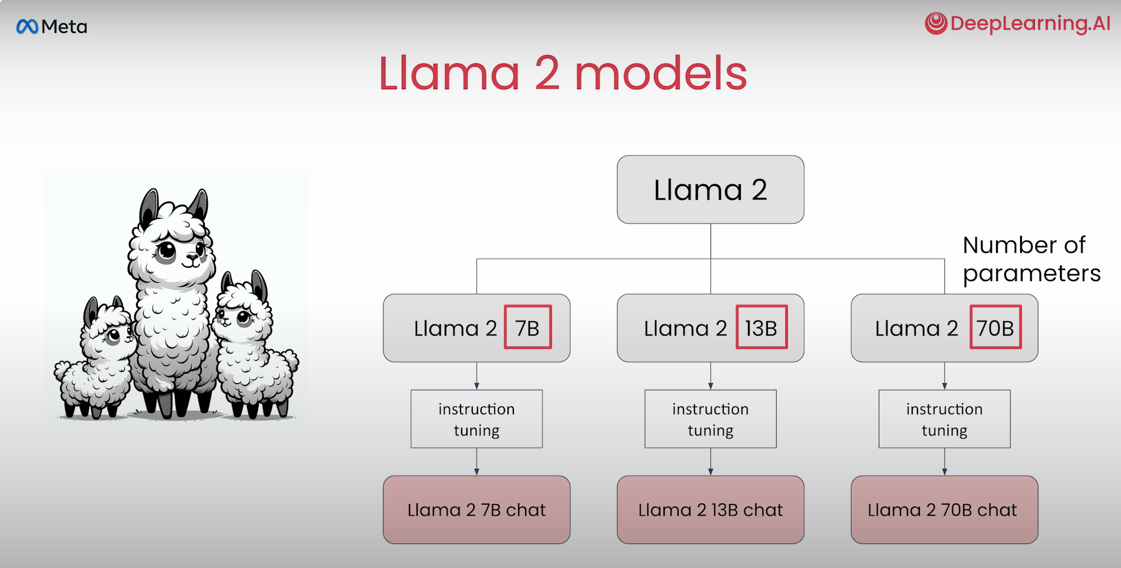

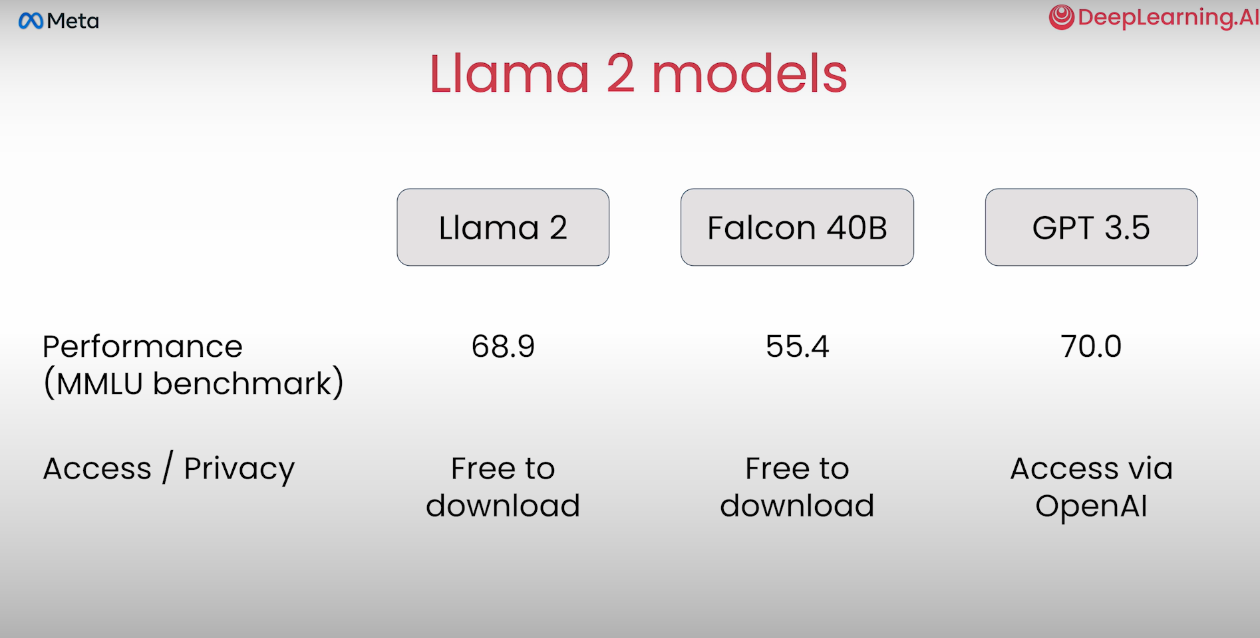

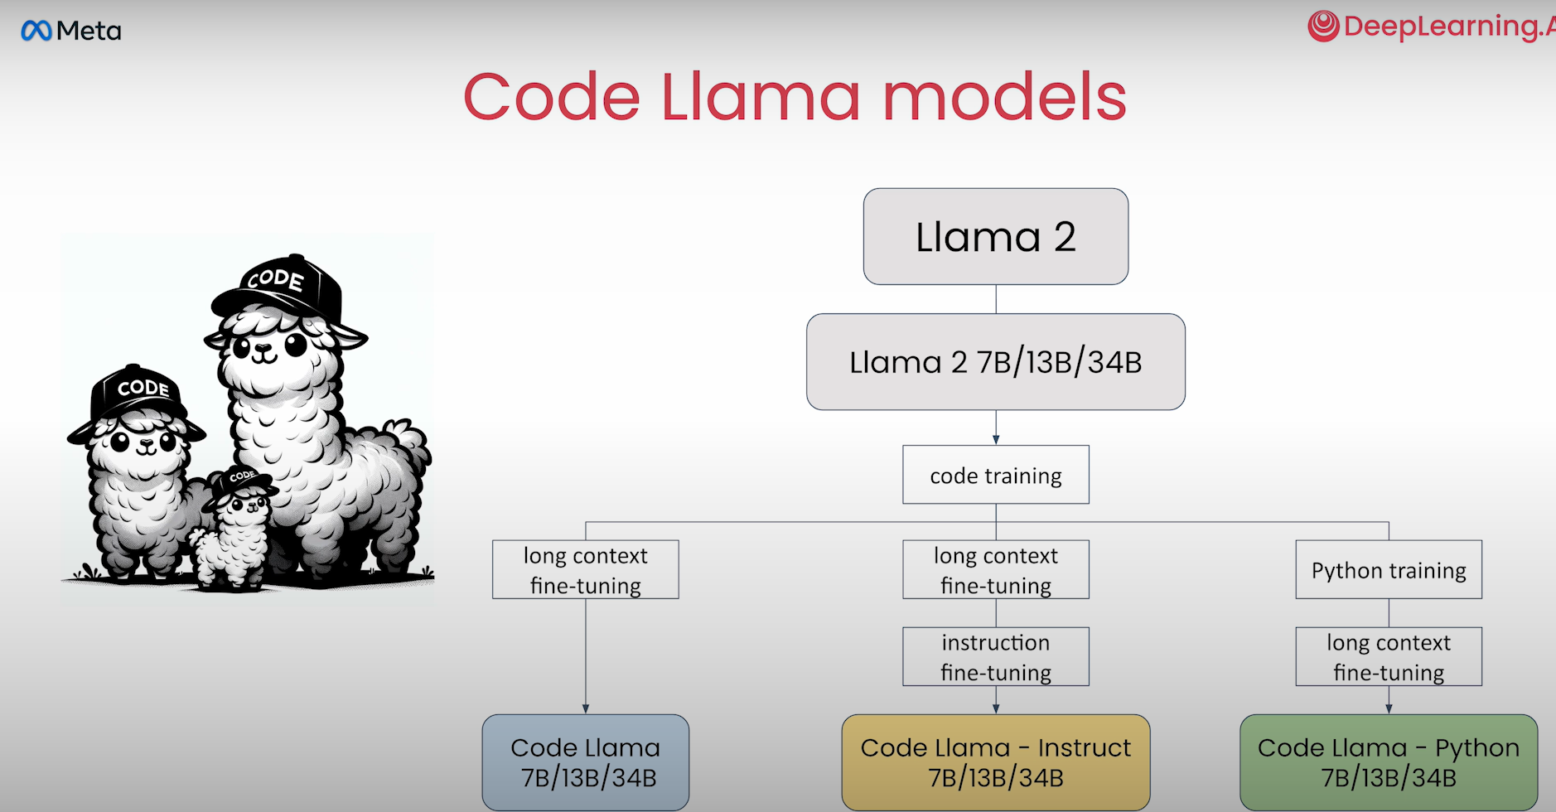

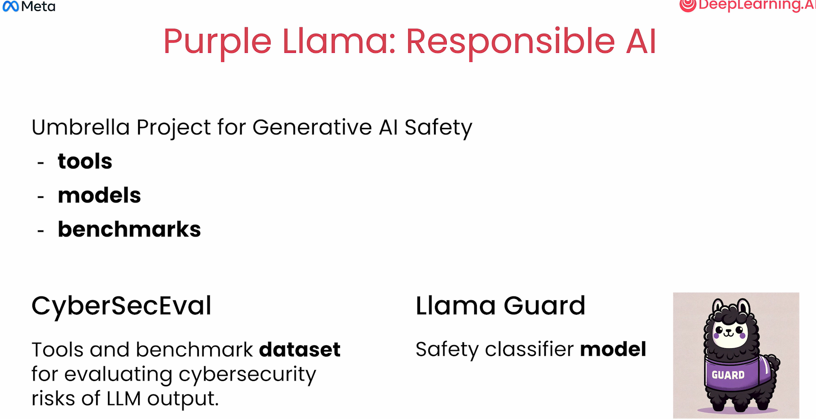

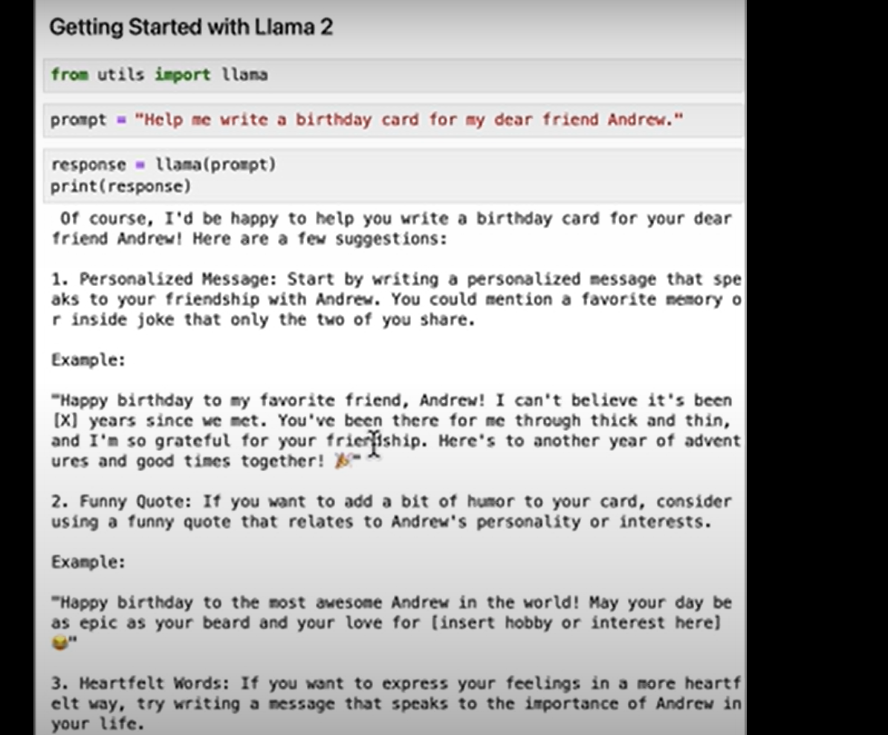

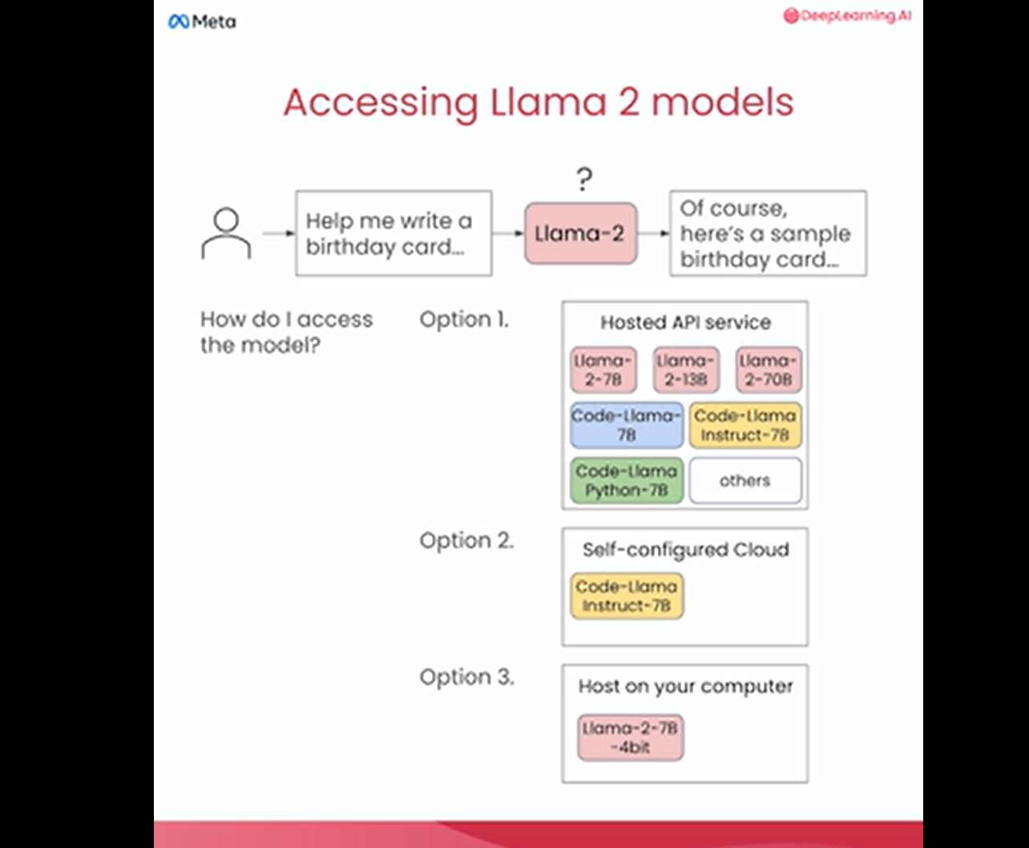

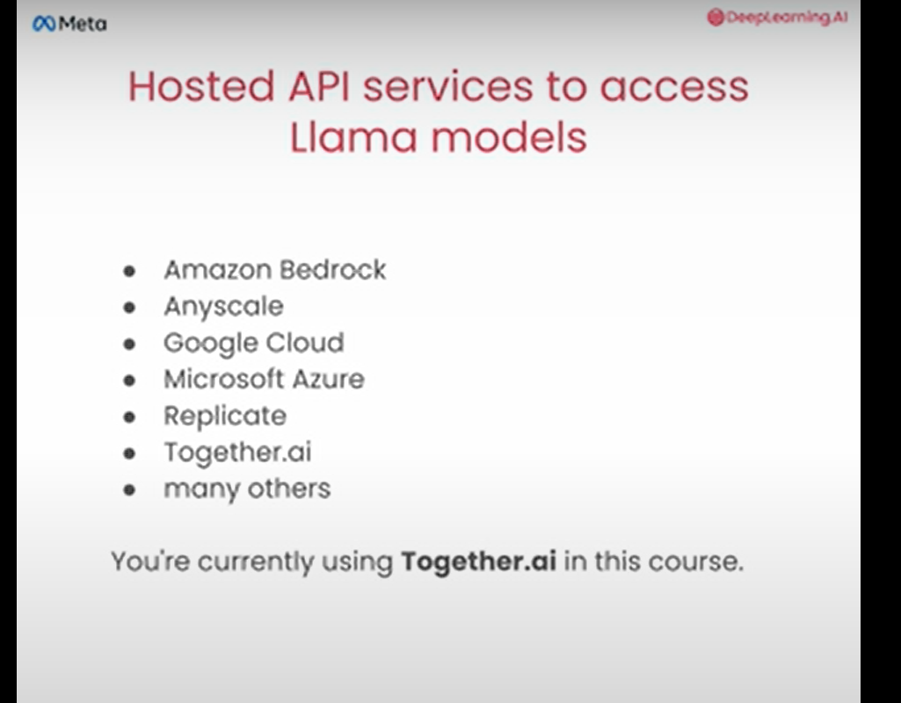

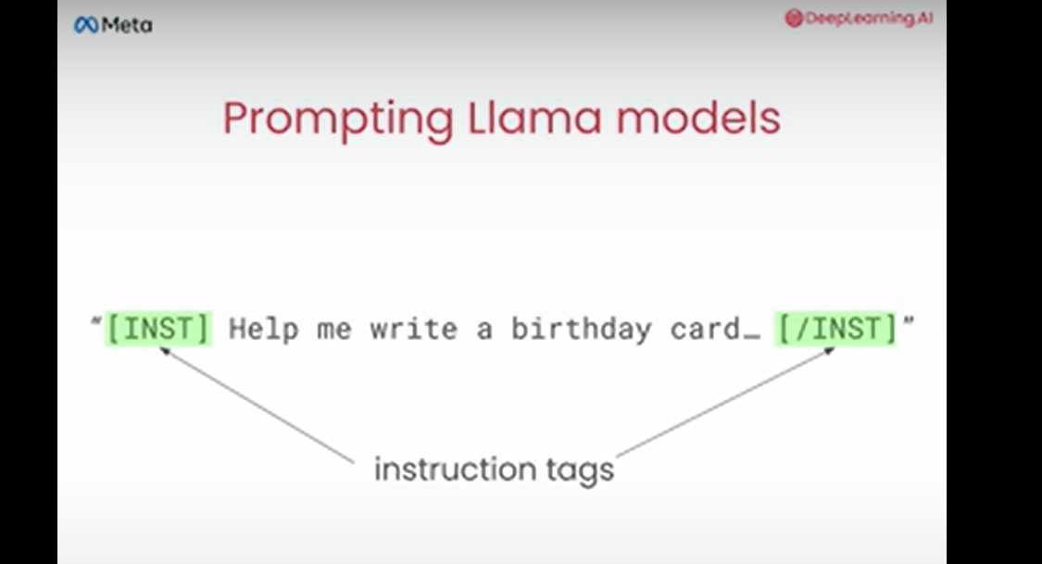

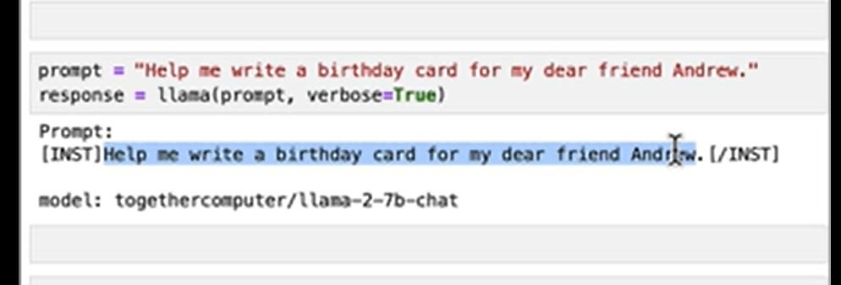

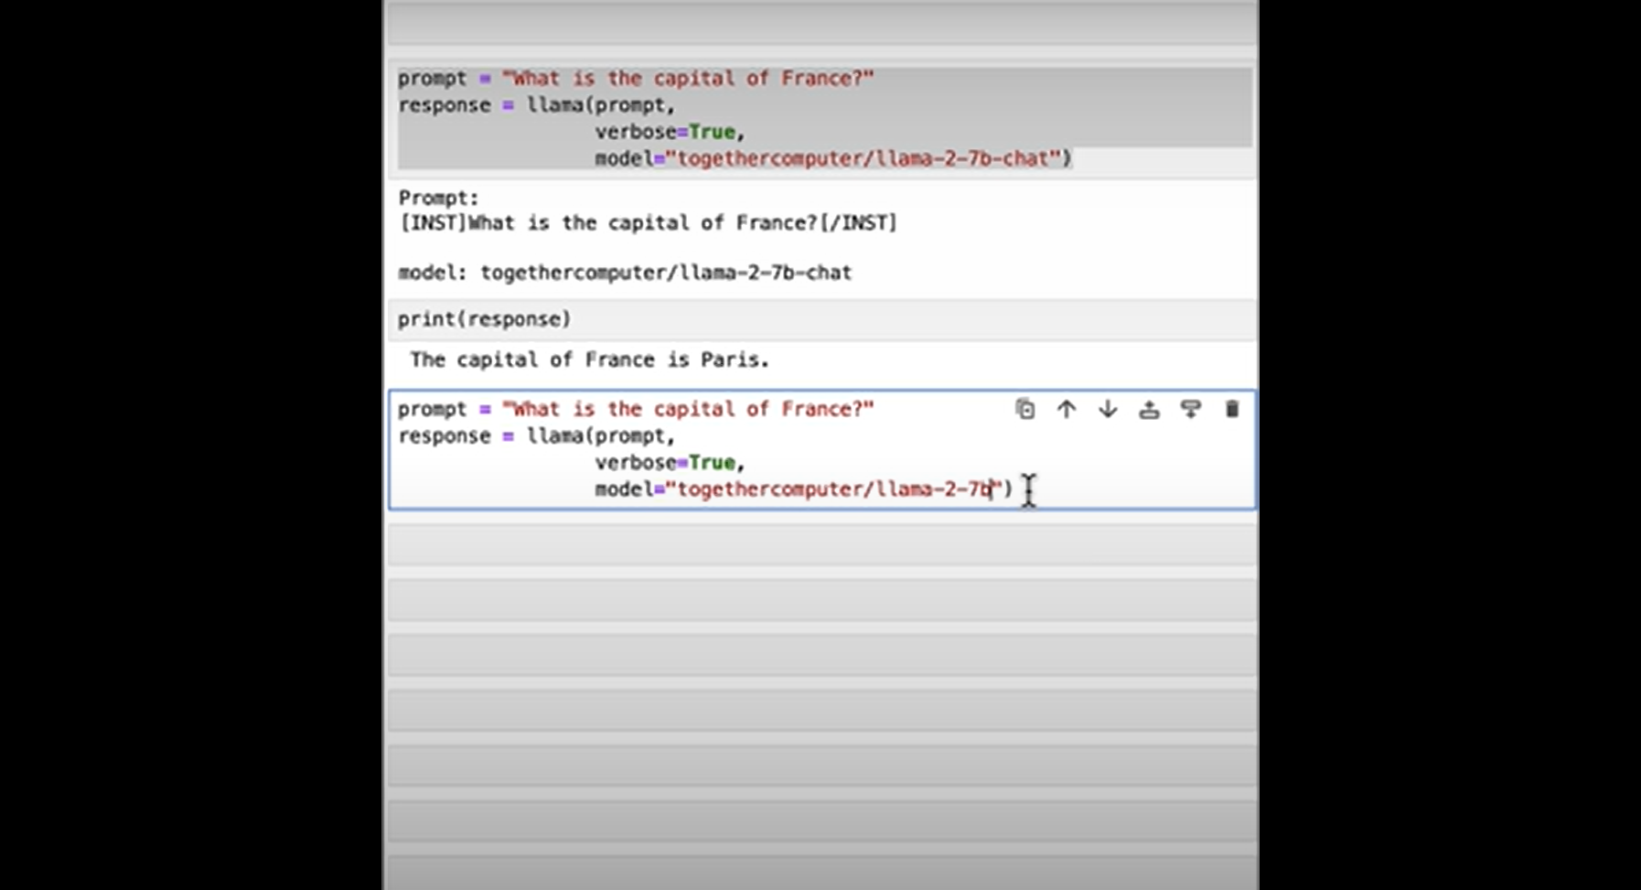

Simple base model not build for answering question but to predict the next word

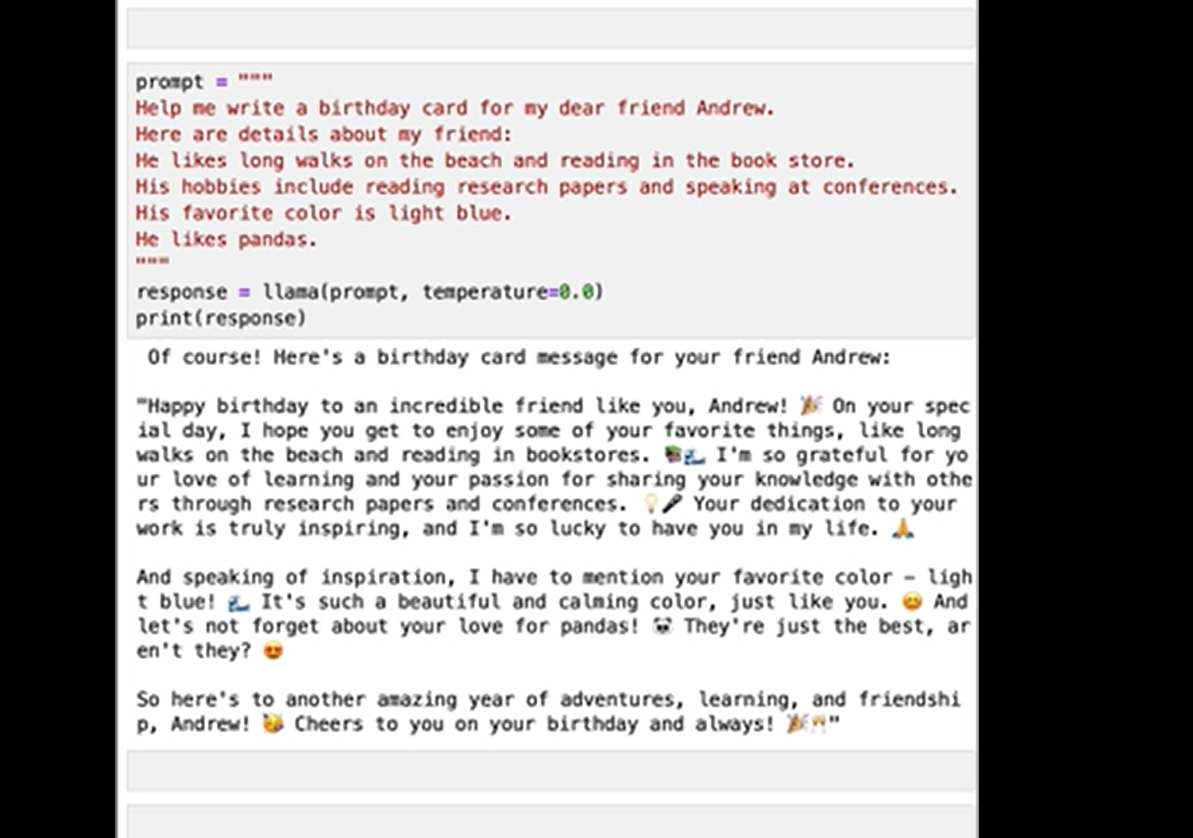

The **temperature** parameter in models like LLaMA (or any generative AI model) controls the randomness or creativity of the output. Here's how it works:

1. **Low Temperature (e.g., 0.0 or close to 0):**
   * The model becomes very deterministic.
   * It always picks the most probable next word or sequence.
   * The output will be straightforward and predictable, often adhering to standard patterns or conventions.
2. **Medium Temperature (e.g., 0.5):**
   * Introduces some variation in the responses.
   * Balances creativity and coherence.
   * Good for tasks where you want a mix of predictability and originality.
3. **High Temperature (e.g., 1.0 or higher):**
   * The model becomes much more creative and diverse.
   * It might take risks in choosing less probable words.
   * Suitable for tasks requiring originality or where diverse outputs are desirable.

**In your example:**

With temperature=0.0, the birthday card generated will be predictable and generic, likely following a standard birthday message template without much flair or uniqueness. If you want the card to be more creative or personal, increasing the temperature (e.g., 0.7) could make it more interesting and varied.

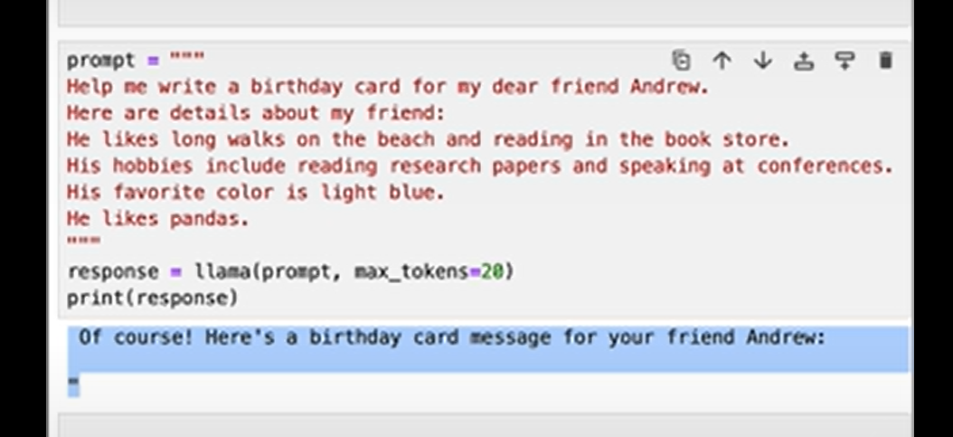

The **token** parameter specifies the maximum number of tokens (words, subwords, or characters depending on the model's tokenization method) the model can generate in response to the prompt.

**What are Tokens?**

* Tokens are the basic units of text that the model processes.
* A token can be as short as one character (e.g., "a"), a part of a word (e.g., "un" in "understand"), or a full word (e.g., "dog"), depending on how the text is tokenized.
* For example, the sentence "Happy birthday!" might tokenize into 3 tokens: "Happy", "birthday", and "!".

**In your example:**

* token=20 means the model will generate up to 20 tokens in its response.
* This limits the length of the output to ensure it doesn't go beyond a short, concise response, like a brief birthday card message.
* If the response completes naturally before 20 tokens, the model will stop early.

**Adjusting the Token Limit:**

* **Lower Token Count (e.g., 10):** Ensures very brief responses, such as a simple greeting.
* **Higher Token Count (e.g., 50+):** Allows the model to create more elaborate or detailed outputs, such as a personalized birthday poem or story.

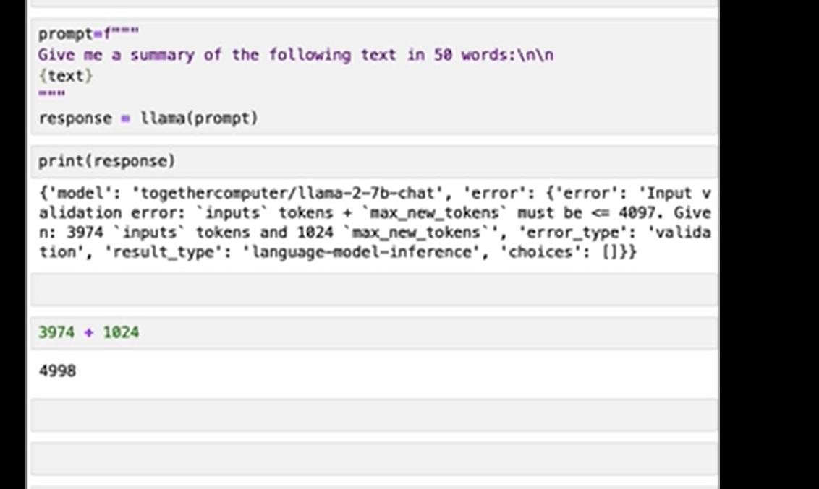

Here there is a certain no of limit >>if I will give too large input then there will be a short output

As there are limited no of tokens in it.

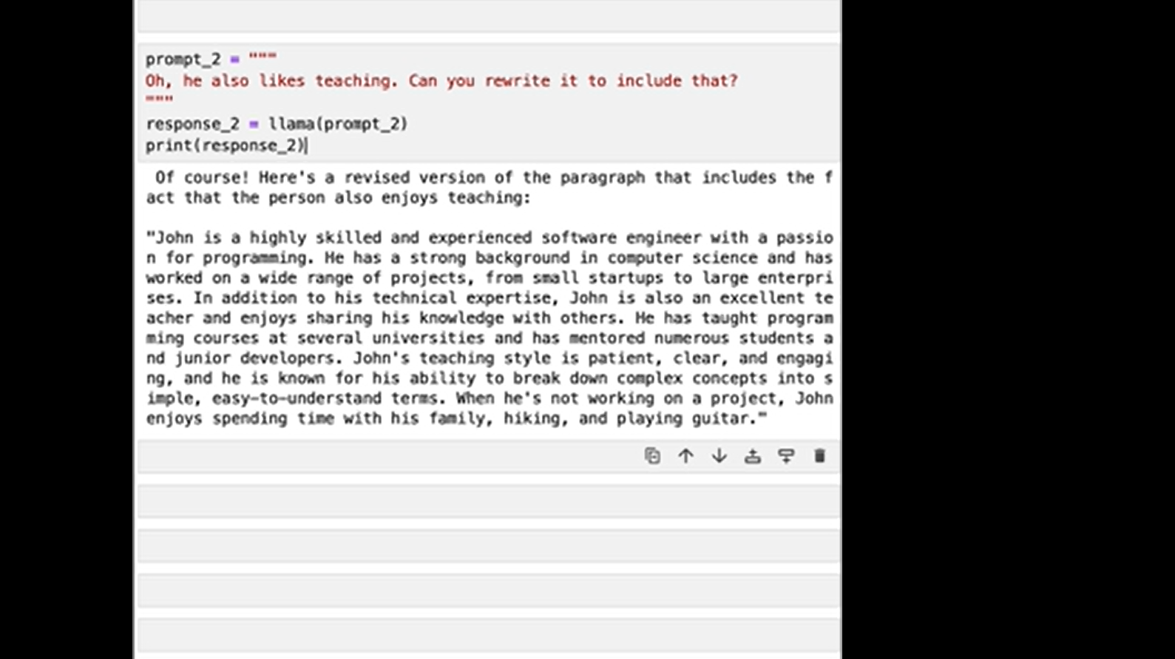

It does not remember the previous data to be provide to user

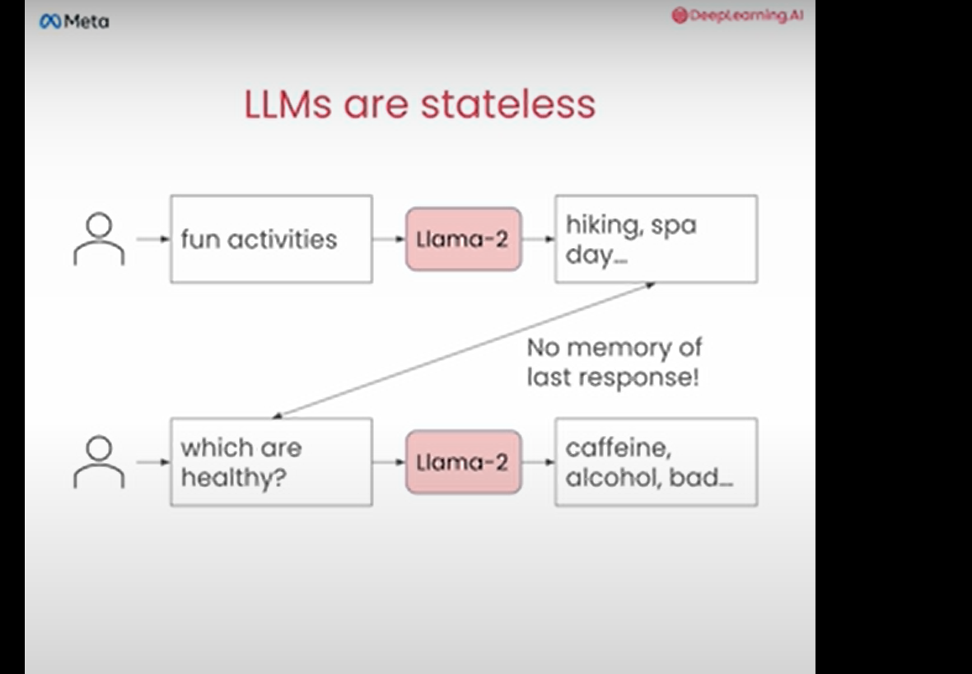

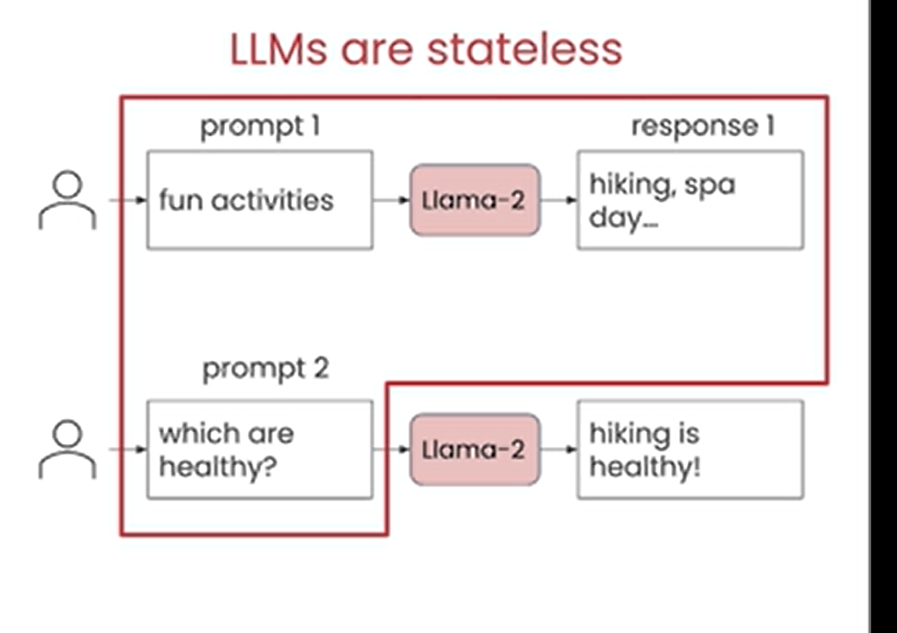

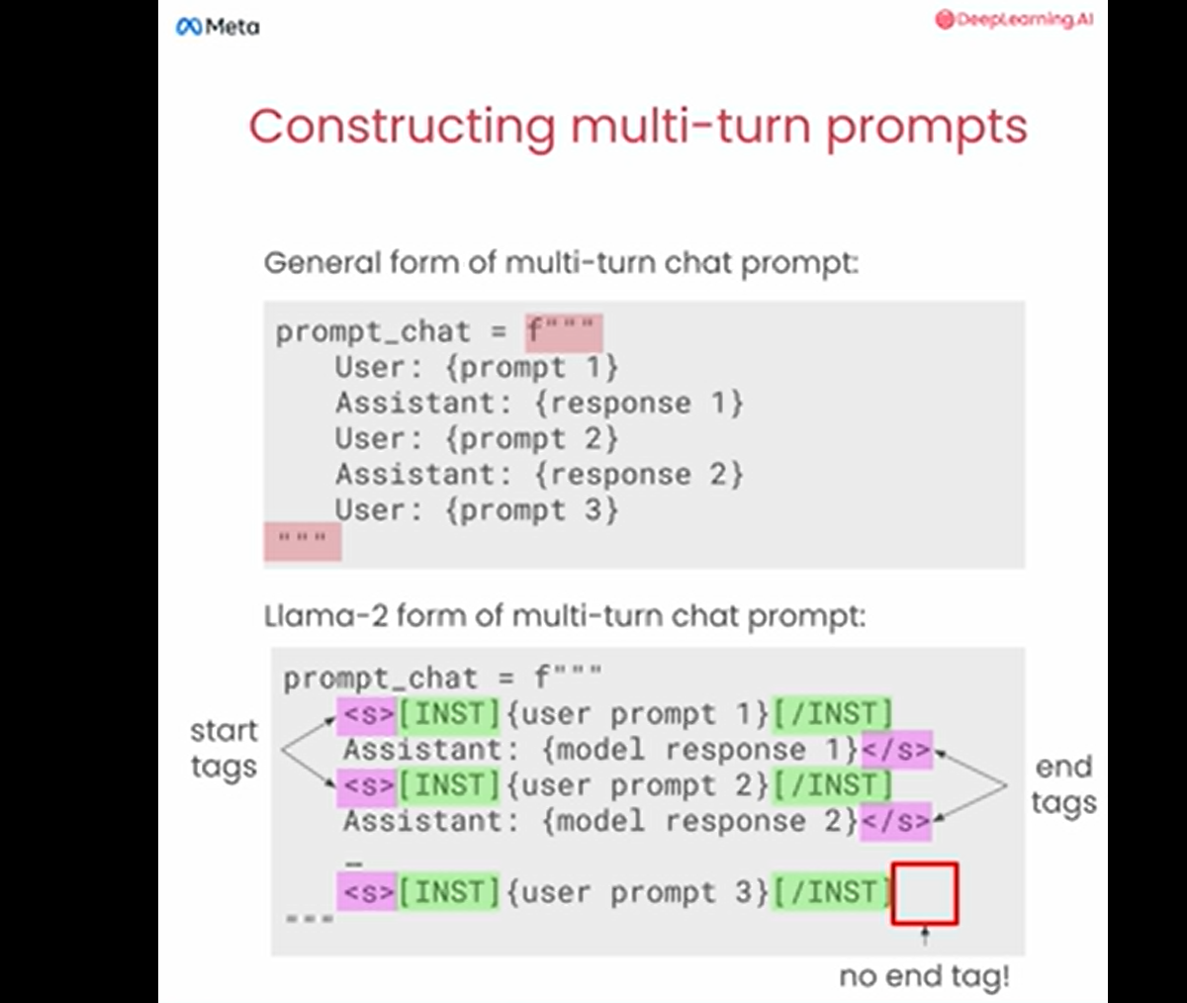

This image shows how to structure multi-turn conversations (like a back-and-forth chat) when working with a language model like LLaMA-2. Let me break it down:

**1. General Multi-Turn Chat Format (Top Part):**

* This is a simple structure where you write:
  + **"User:"** followed by what the user says.
  + **"Assistant:"** followed by what the model responds.
* Each interaction (turn) alternates between the user and the assistant.
* Example:
* User: What's the weather today?
* Assistant: It's sunny and 25°C.
* User: Should I carry an umbrella?

**2. LLaMA-2 Multi-Turn Format (Bottom Part):**

* LLaMA-2 uses **special tags** to indicate who is speaking and separate different parts of the conversation.
* **Key elements:**
  + <s>[INST] at the beginning of a user prompt to show it's the user speaking.
  + [/INST] at the end of the user's message.
  + The assistant's response follows immediately after the [/INST].
  + The conversation repeats this format for every turn.
* Example:
* <s>[INST]What's the weather today?[/INST] It's sunny and 25°C.</s>
* <s>[INST]Should I carry an umbrella?[/INST]

Notice:

* + The assistant’s response (e.g., "It's sunny...") is inside the same block as the closing tag (</s>).
  + The **last user prompt does not have a closing tag** because the assistant hasn't responded yet.

**Why This Format?**

* It helps the LLaMA-2 model understand who is speaking (user or assistant).
* The tags (<s>[INST], [/INST], </s>) help organize the conversation and train the model to behave like an assistant.

This formatting ensures that multi-turn conversations are clear and logical for the model to process.

**Step 1: When You Talk to the Robot**

You start by saying:

* **“Hey robot, I have a question!”**
* To tell the robot it’s your turn, you use this **magic signal**:
* <s>[INST]
* Then, you write your question, like:
* What's your favorite color?
* And when you’re done, you close your turn with this:
* [/INST]

So, your message to the robot looks like this:

<s>[INST]What's your favorite color?[/INST]

**Step 2: When the Robot Replies**

The robot says:

* **“Okay, here’s my answer!”**
* It writes its response (e.g., "My favorite color is blue!") and ends it with this:
* </s>

So, the robot's reply looks like this:

My favorite color is blue!</s>

**Step 3: When You Talk Again**

Now it’s your turn again. You repeat the same thing:

1. Start with:
2. <s>[INST]
3. Write your question or comment:
4. What about red?
5. Close your turn with:
6. [/INST]

It looks like this:

<s>[INST]What about red?[/INST]

**Why the Tags Are Important**

The robot isn’t as smart as humans when it comes to conversations—it doesn’t "guess" who’s speaking. Instead, it relies on these **tags**:

* <s>[INST] → Tells the robot, "The user is speaking now!"
* [/INST] → Says, "The user is done talking."
* </s> → Means, "The robot is done replying."

**Putting It All Together**

Here’s a full conversation:

1. **You ask:**
2. <s>[INST]What's your favorite color?[/INST]
3. **Robot replies:**
4. My favorite color is blue!</s>
5. **You ask again:**
6. <s>[INST]What about red?[/INST]

**Why Does the Last Question Have No End Tag?**

When you end with:

<s>[INST]What about red?[/INST]

You **don’t add </s> yet**, because the robot hasn’t replied yet! You’re just waiting for it to answer.

**Visualize It Like a Ping-Pong Game:**

* **You hit the ball:** <s>[INST]What's your favorite color?[/INST]
* **Robot hits it back:** "My favorite color is blue!</s>"
* **You hit it again:** <s>[INST]What about red?[/INST]
* **Robot is about to hit back!**

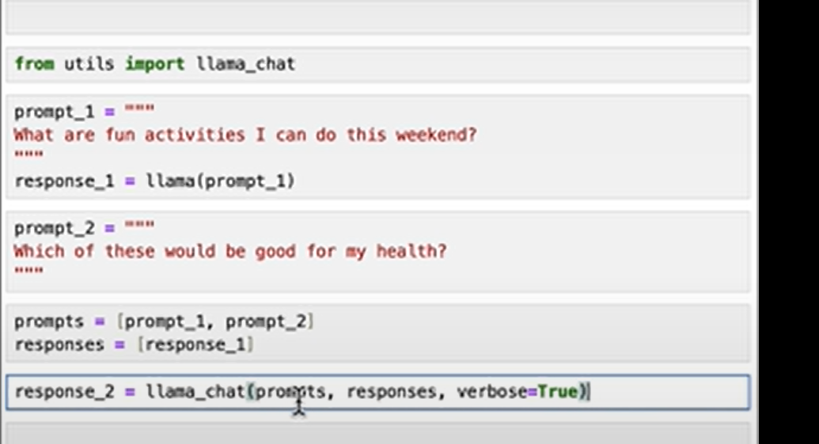

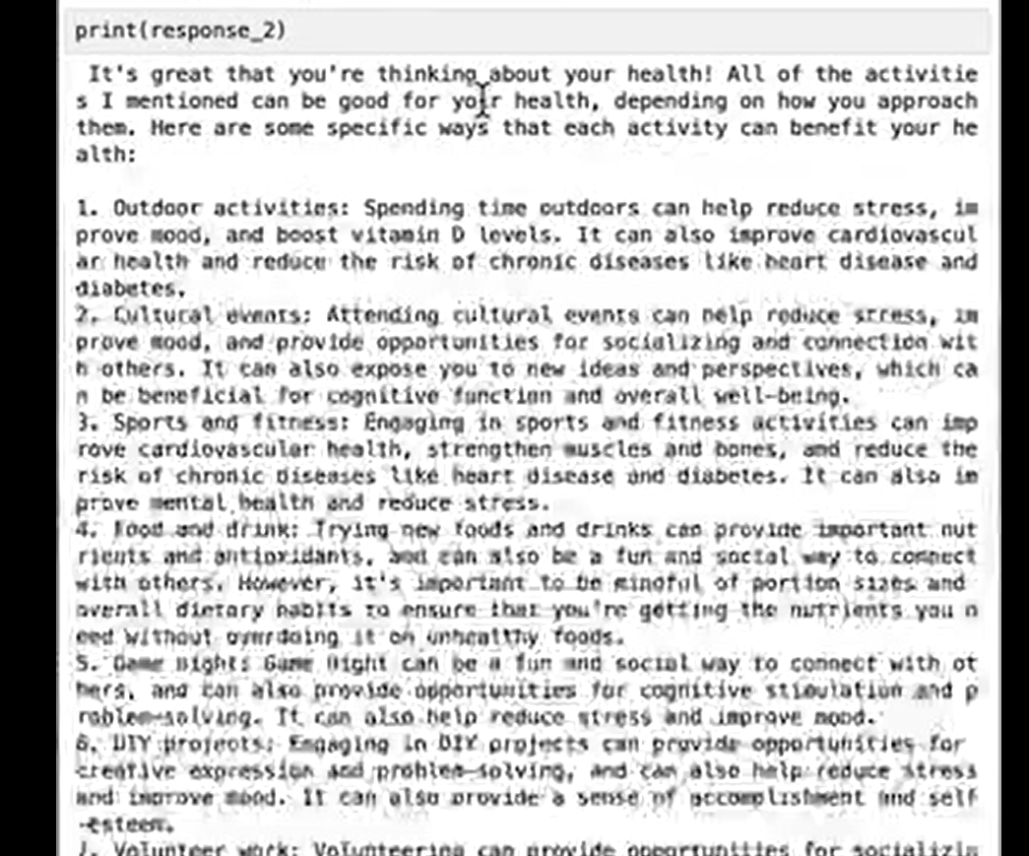

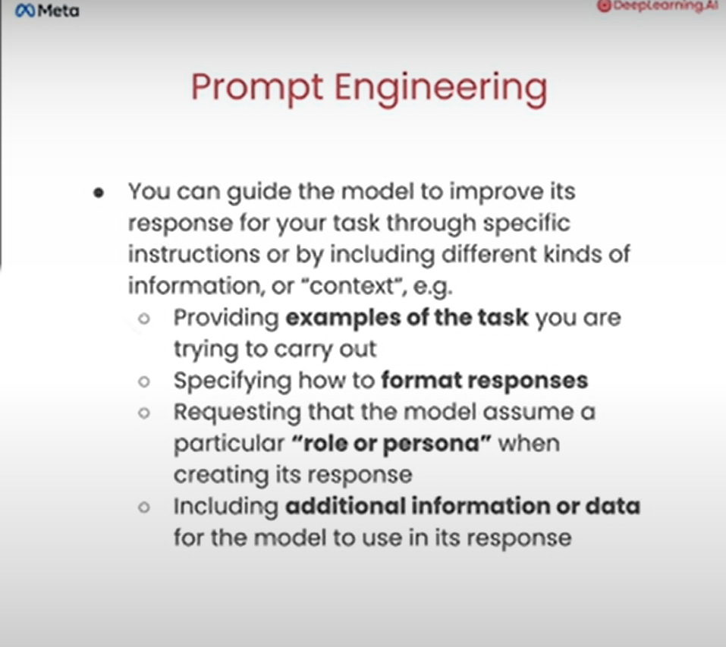

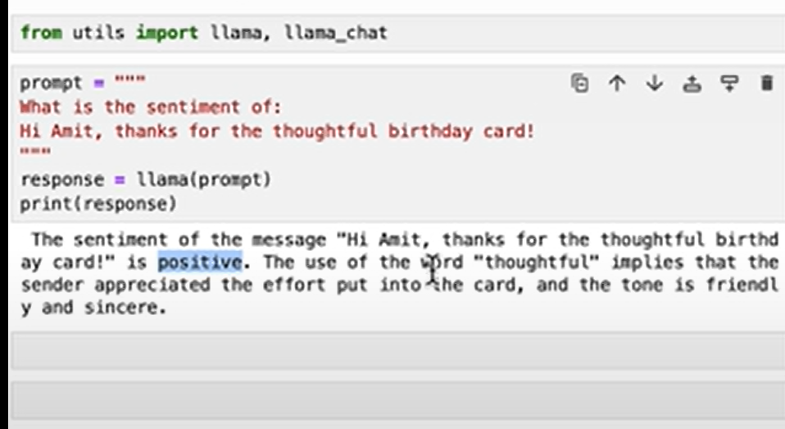

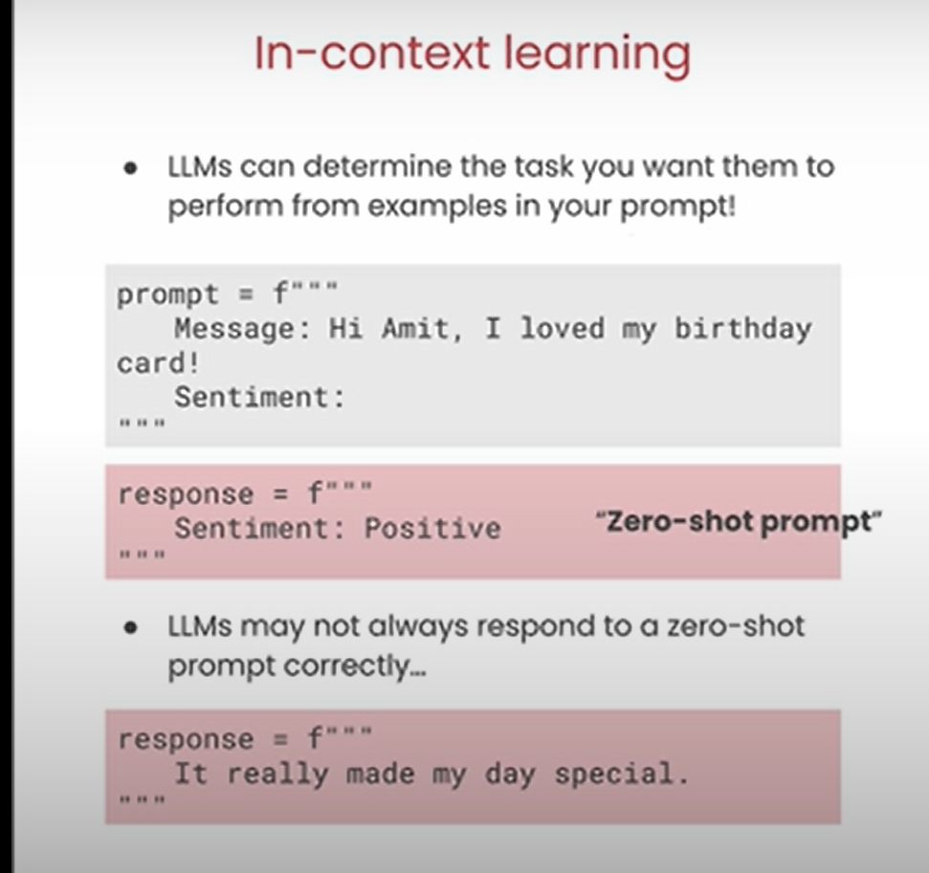

A **zero-shot prompt** is when you ask a language model (like LLaMA-2 or GPT) to perform a task **without giving it any examples** of how to do it. You simply provide the instructions or question directly, and the model has to figure out what to do based on its prior training.

**Why is it called "Zero-Shot"?**

* It’s like taking a "shot" at solving a problem without seeing any examples beforehand. The model is expected to generalize from the prompt alone.

**How Zero-Shot Prompting Works**

In zero-shot prompting:

1. You give **only instructions** or a question.
2. The model uses its understanding of language and knowledge to generate the response.

**Example 1: Zero-Shot Prompt for Summarization**

**Prompt:**

"Summarize this article: The moon is Earth's only natural satellite. It influences the tides and has been explored by astronauts."

**Model's Response:**

"The moon is Earth's natural satellite, influencing tides and explored by astronauts."

**Example 2: Zero-Shot Prompt for Translation**

**Prompt:**

"Translate this sentence into Spanish: I am learning how to prompt language models."

**Model's Response:**

"Estoy aprendiendo a usar modelos de lenguaje."

**When to Use Zero-Shot Prompting?**

* When you need quick, simple answers.
* When the task is **straightforward** or common (e.g., summarizing, translating, or answering factual questions).

**Zero-Shot vs Few-Shot Prompting**

| **Feature** | **Zero-Shot** | **Few-Shot** |
| --- | --- | --- |
| **Definition** | No examples provided, just instructions. | Examples of the task are given in the prompt. |
| **Complexity** | Works well for simple or well-known tasks. | Better for complex or specific tasks. |
| **Example Requirement** | None. | Examples of inputs and outputs are included. |

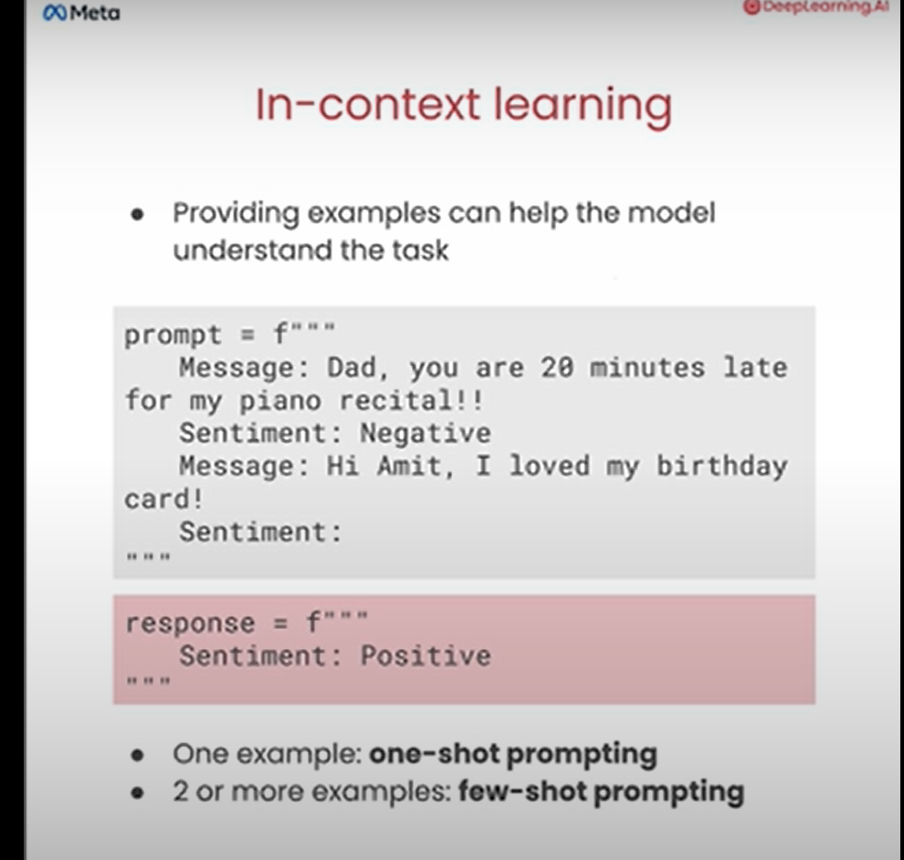

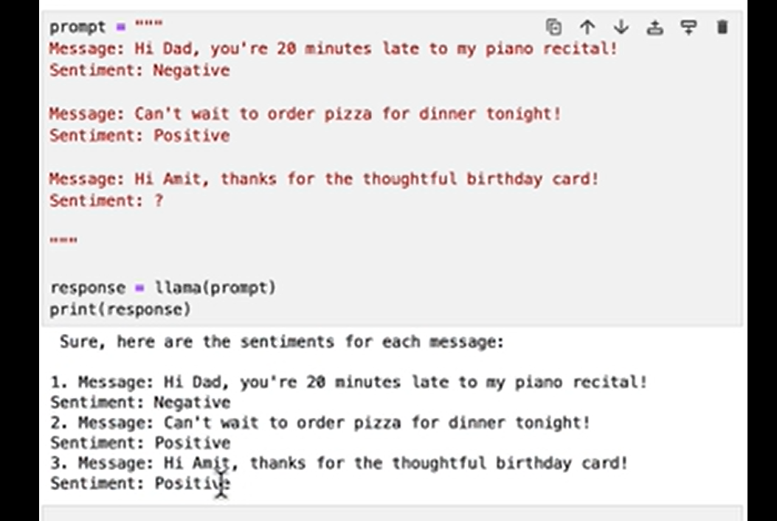

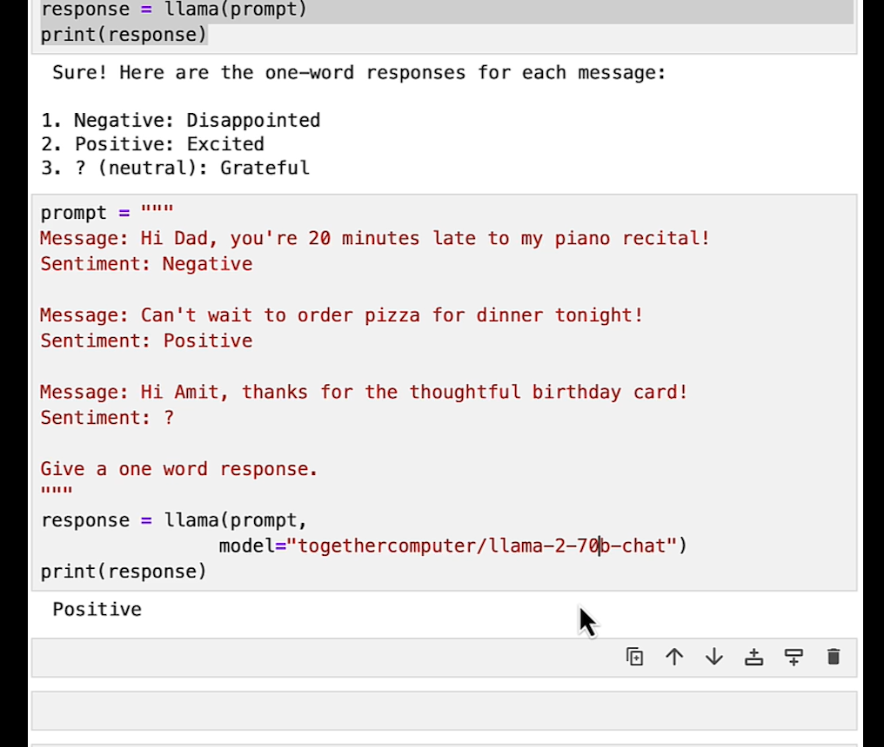

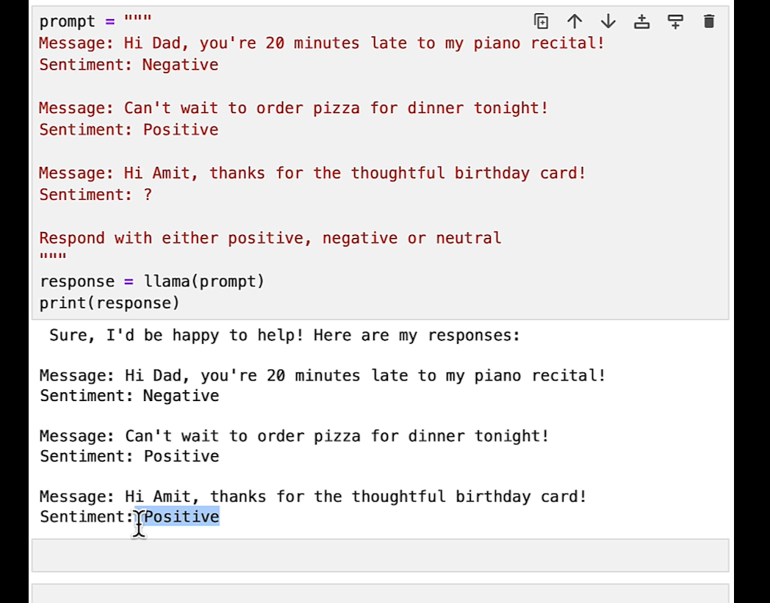

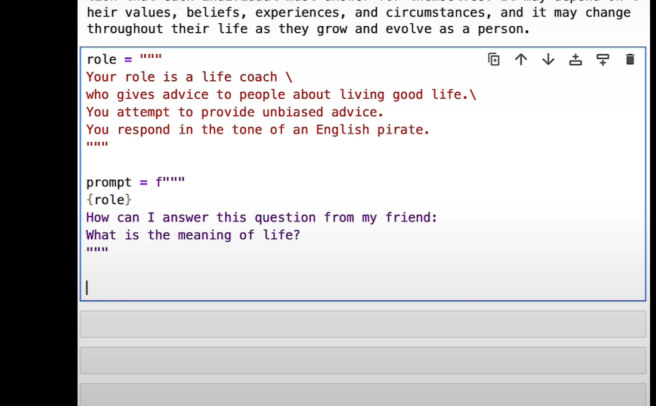

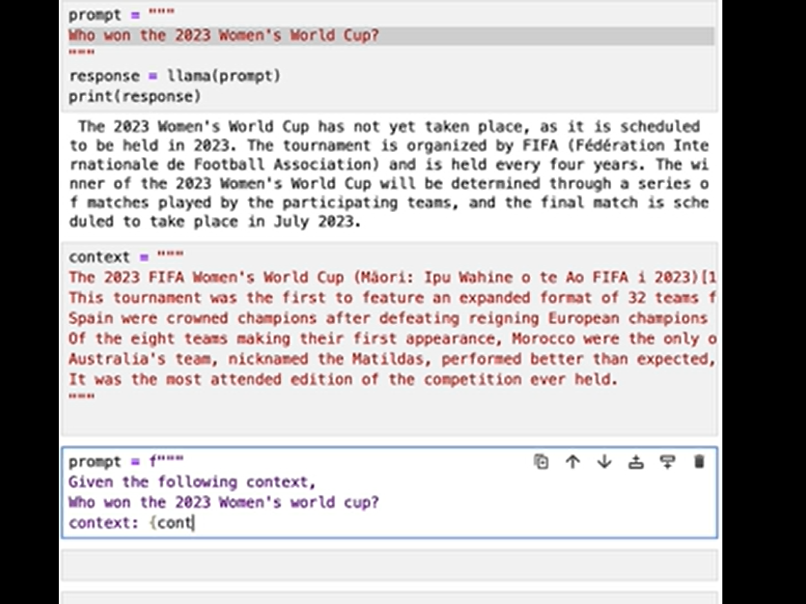

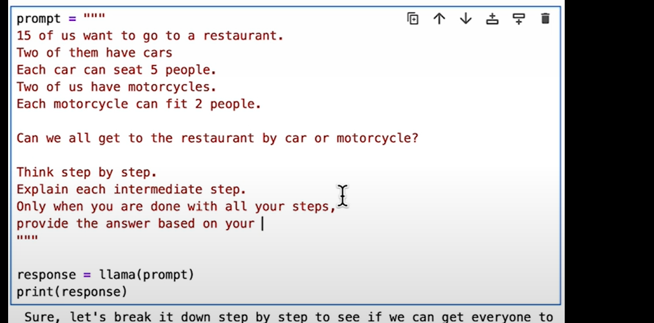more instructions to model

